Game Design Document
Game Rules:
- The player will not be able to exit the borders of the screen, and will bounce off the edges, allowing them to easily change direction by rebounding to escape, however they will lose speed from this to discourage spamming escape bounces.
- The player can heal upon hitting an enemy at high enough speed, encouraging them to go for risky plays if they can move fast enough.
- The enemies however, can be knocked off screen, encouraging the player to play closer towards the center if they want to get multiple hits on the enemy.
- The player wont receive any stat boosts upon levelling up (perhaps allowing for a health restoration if necessary), I intend on making the main focus of levelling up getting upgrades.
- The player can click and hold anywhere to fling their character. I decided to make the movement system this way as the standard WASD method of movement wouldn’t allow for as snappy of movements that way.
- When the player is fast enough, they wont take contact damage and can damage other enemies. Encouraging them to move quickly and avoid downtimes between movements
- Certain enemies will slow down/immobilize the player without damaging them to get them to dodge rather than moving in a straight line all the time. E.g. the minelayer will place obstacles to get the player to move out of the way

Key Algorithms:
- The game will use a director that gains credits to use overtime in order to spawn enemies, gaining more to spend overtime.
- The Upgrade system will randomly pick between 3 upgrades for the player to use overtime, it will attempt to select upgrades that branch off of others.

Control Scheme:
- Mouse click and drag will be used to direct the player’s movement.
- Space will allow them to quickly brake so they can avoid flinging themselves into danger
- Mouse clicks will be used to decide upgrades on the menu as well as navigate the pause menu.

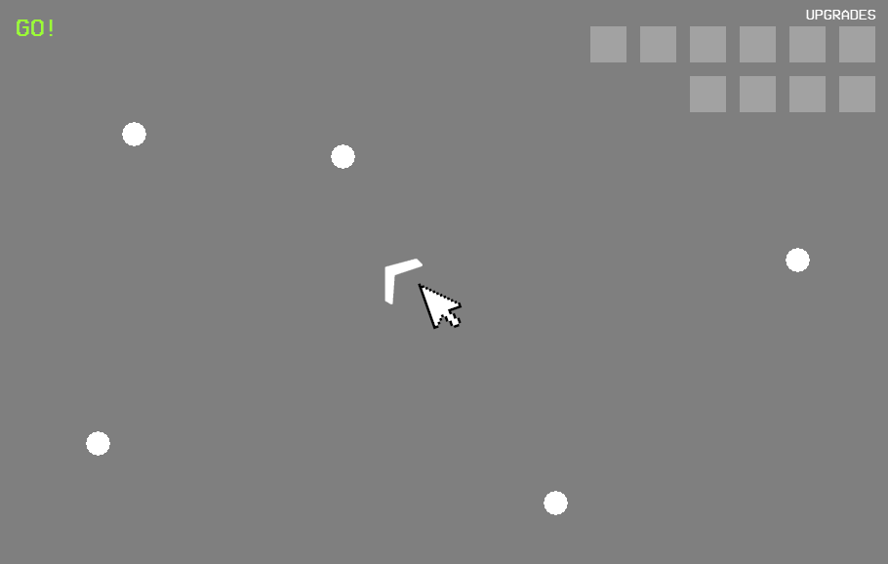
Mockup:

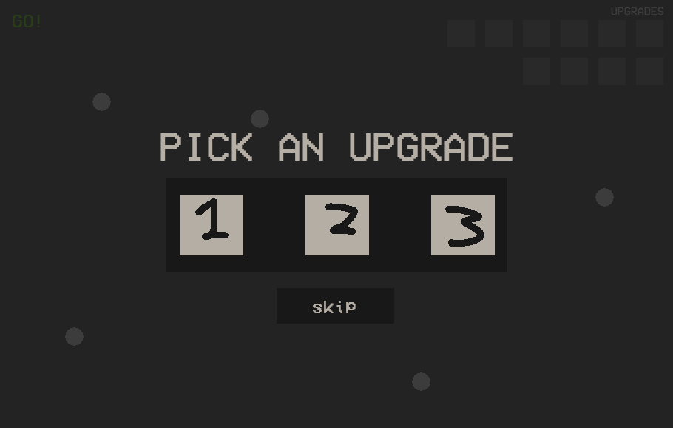

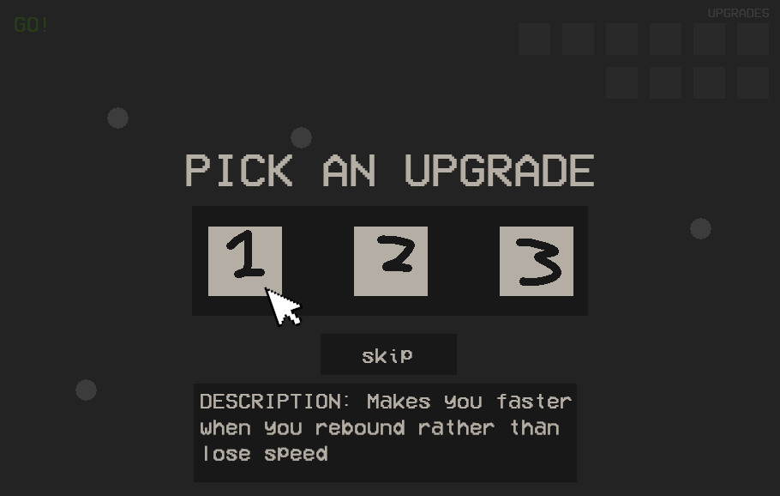

Cheat Features:
- No speed loss
- God-mode/invincibility
- 1 shot
- All Upgrades

Asset List:
- Sprites
  - Player icon
  - Enemy icons
  - Upgrade icons
  - Particles for player movement fast enough, mouse dragging, and enemy projectiles
  - Tracer Projectiles
- Audio
  - Hit
  - Enemy death
  - Level up
  - Bounce
  - Knocking an enemy away
  - Background music
  - Startup Sound

